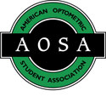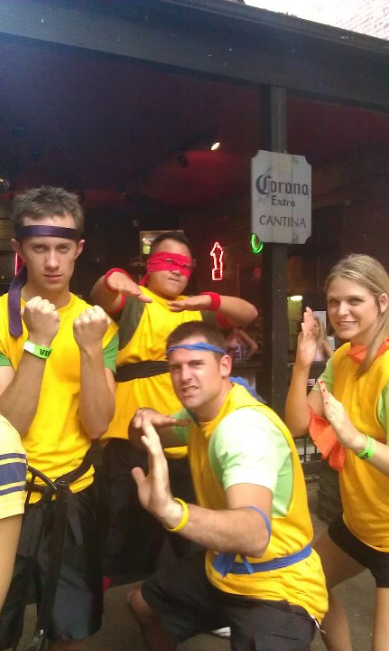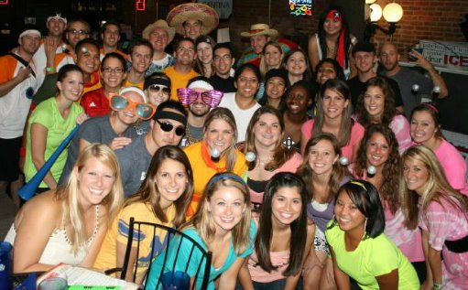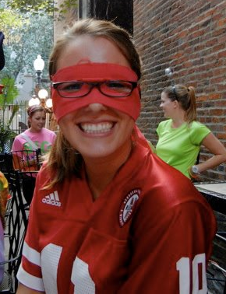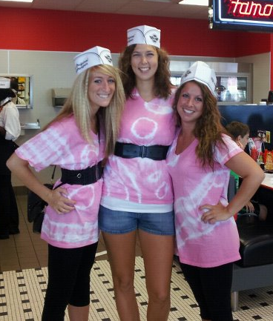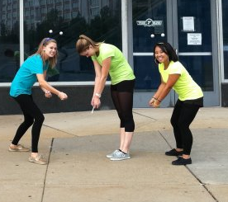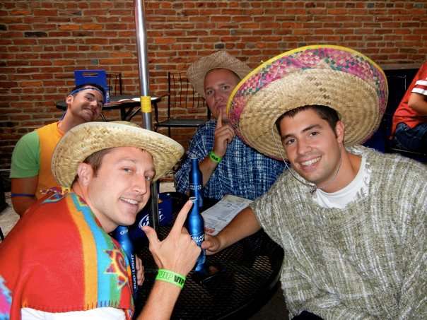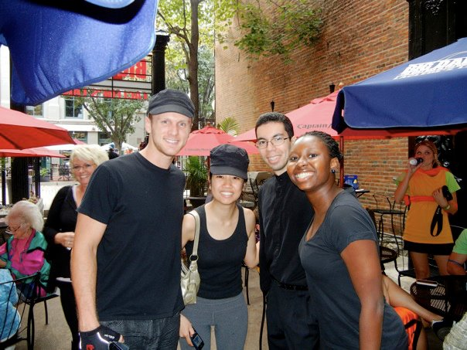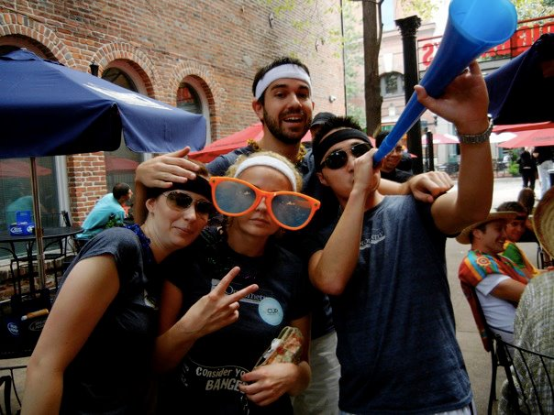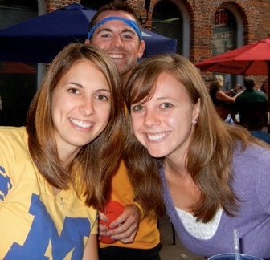

**“THE RUNNING RETINA” ROAD RALLY  
  
“**

**Help raise money for Eyeball formal and have fun with your peers at the same time!**

$40/team, no more than 4 people per team

**Date: September 28, 2012**  **Time: 1:30pm**

**PRIZES:**

**1st:** 1 free pair of lenses/person courtesy of Midland Optical, + entry fee returned + round of drinks or 2 appetizers + 5 raffle tickets/person

**2nd:** round of drinks or 2 appetizers + 5 raffle tickets/person

**3rd:** 3 raffle tickets/person

**THE RUNNING RETINA ROAD RALLY**